**Updated Architecture:**

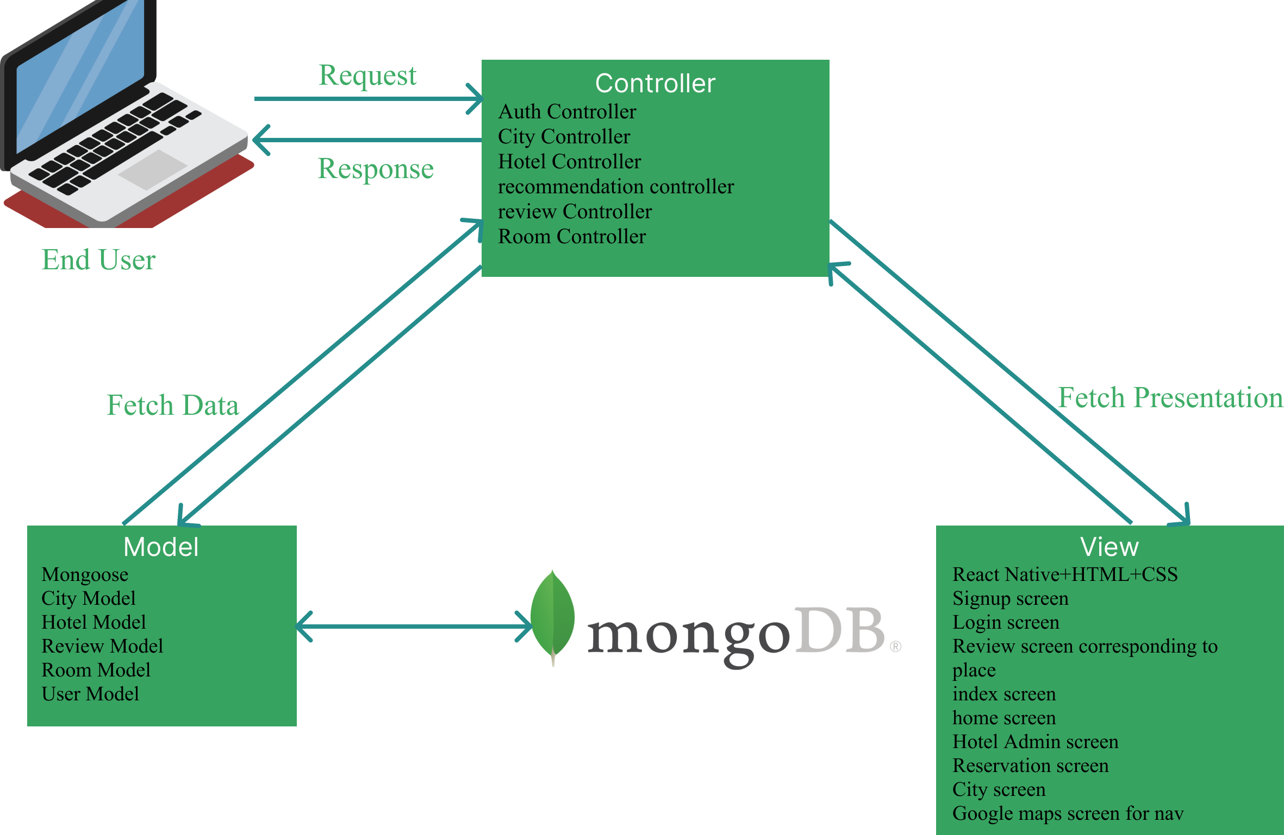

**Views (React Native Components)**

1. **City Screen**: Allows users to view all the famous places in the city.
2. **Review Screen**: Displays and allows users to add reviews for destinations.
3. **Google Maps Screen**: Shows the map and route details using Google Maps API.
4. **Signup screen**: Allows secure signup of users into database.
5. **Login screen**: Allows login for registered users.
6. **Index screen**: Routes to either signup or login screen.
7. **Home** screen: Lets users select from list of hardcoded cities and features a search bar.
8. **Hotel Admin screen:** Screen for hotel administrator to edit details of hotels and approve bookings.
9. Reservation screen: Allows users to make bookings.

**Backend (Express.js Components)**

1. **Routes**: Define API endpoints for communication with the frontend.

* /signup: User Signup.
* /login: User login.
* /getReviews
* /postReviews
* /GetGoogleNavigation
* /getCities
* /getRecommendations
* /getHotels
* /postHotel
* /getHotelByName
* /getHotelByUsername
* /getRooms
* /postRooms
* /getRoomsByHotel
* /getSearchPlaces

1. **Controllers**:

Contains business logic.

1. **AuthController**: Handles user authentication and authorization.
2. **ReviewController**: Handles reviews creation and retrieval.
3. **CityController**: Handles cities retrieval.
4. **HotelController:** Handles hotel creation, retrieval of all hotels, retrieval of hotel through hotel name and retrieval of hotel through hotel admin name.
5. **RoomController:** Handles room creation, retrieval, and retrieval by hotel.
6. **RecommendationController:** Handles search and recommendations.

1. **Middleware**:

Intercepts requests for validation and security.

1. **AuthMiddleware**: Verifies authentication tokens.

1. **Database Layer**

* **User Model**: Stores user account information (username, email, password).
* **Review Model**: Stores user reviews (username, place name, comment, rating).
* **Hotel Model**: Stores hotel information (name, location, description, ref to rooms).
* **Room Model**: Stores room information (room type, price, duplicates, number booked, available, ref to hotel).
* **City Model**: Stores information about cities (name, country, description, places, food, photo Url, coordinates.)

**External Services**

1. **Google Maps API**: Powers navigation and location-based services.

**Updated Data model/ ER diagram:**

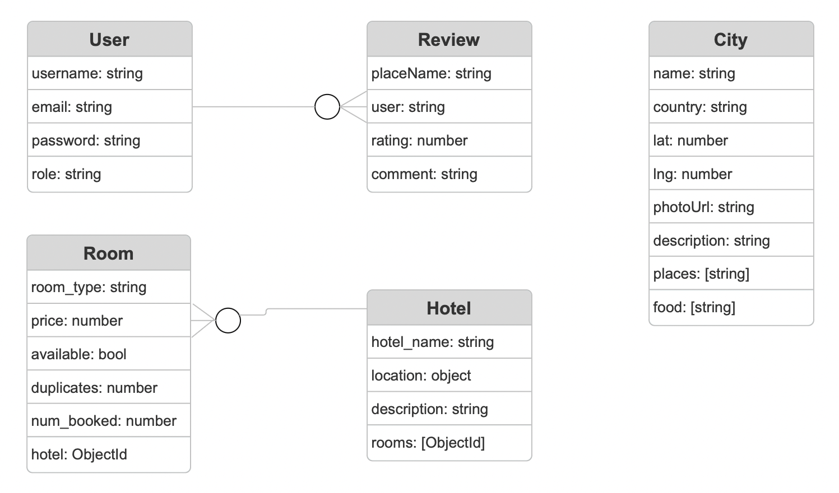

**User: all users interacting with the application (admins, consumers, hotel staff).**

Username: visible name on platform for the user for reviews.

Email: to ensure uniqueness of users and valid accounts.

Password: to ensure account security.

Role: to check if user is customer or hotel admin.

**Review: review left by user on destination.**

Username: to store and display the associated user that made the review.

Place name: to store and display which destination the review was left on.

Comment: comment left by user.

Rating: out of 5 ratings assigned by user.

**Hotel: hotels available on the platform for booking.**

Hotel name: name of the hotel.

Location: location of the hotel. (type object to store coordinates, address, city country etc.)

Description: description of hotel assigned by hotel staff.

Rooms: array of references to room objects.

**Room: room to be booked by user at specified hotel.**

Price: price specified by hotel staff.

Available: bool to check if room is available.

Room type: type of room: deluxe, executive, presidential suite etc.

Duplicates: number of such rooms available at the hotel.

Hotel: reference to hotel that room is associated with.

Num Booked: number of duplicates for the hotel that have been booked.

City: city in which the user lives or is searching for.

Name: name of city.

Country: country that city belongs to.

Lat: latitude of city for navigation.

Lng: Longitude of city for navigation.

Photourl: picture associated with city.

Description: description of the city.

Places: list of different places such as sites or hotels. (currently configured for hotels only).

Food: list of food options in city.